Exercise 1: Mocking and Stubbing
Scenario:
You need to test a service that depends on an external API. Use Mockito to mock the external API and stub its methods.
Steps:
1. Create a mock object for the external API.
2. Stub the methods to return predefined values.
3. Write a test case that uses the mock object.

Solution-
Adding dependencies:

<project xmlns="http://maven.apache.org/POM/4.0.0"
xmlns:xsi="http://www.w3.org/2001/XMLSchema-instance"
xsi:schemaLocation="http://maven.apache.org/POM/4.0.0 https://maven.apache.org/xsd/maven-4.0.0.xsd">

<modelVersion>4.0.0</modelVersion>
<groupId>in.cognizant</groupId>
<artifactId>MockitoExercises</artifactId>
<version>0.0.1-SNAPSHOT</version>

<dependencies>
<dependency>
<groupId>org.junit.jupiter</groupId>
<artifactId>junit-jupiter</artifactId>
<version>5.7.0</version>
<scope>test</scope>
</dependency>

<dependency>
<groupId>org.mockito</groupId>
<artifactId>mockito-core</artifactId>
<version>3.12.4</version>
<scope>test</scope>
</dependency>
</dependencies>

</project>

1. External API Interface

package in.cognizant;

public interface ExternalApi {
String getData();
}

2. Methods to return predefined values
package in.cognizant;

public class MyService {
private ExternalApi api;

public MyService(ExternalApi api) {
this.api = api;
}

public String fetchData() {
return api.getData();
}
}

3. Test case that use mock object
package in.cognizant;

import static org.junit.jupiter.api.Assertions.assertEquals;
import static org.mockito.Mockito.mock;
import static org.mockito.Mockito.when;
import org.junit.jupiter.api.Test;

public class MyServiceTest {

@Test
public void testExternalApi() {
ExternalApi mockApi = mock(ExternalApi.class);
when(mockApi.getData()).thenReturn("Mock Data");
MyService service = new MyService(mockApi);
String result = service.fetchData();
assertEquals("Mock Data", result);
}
}

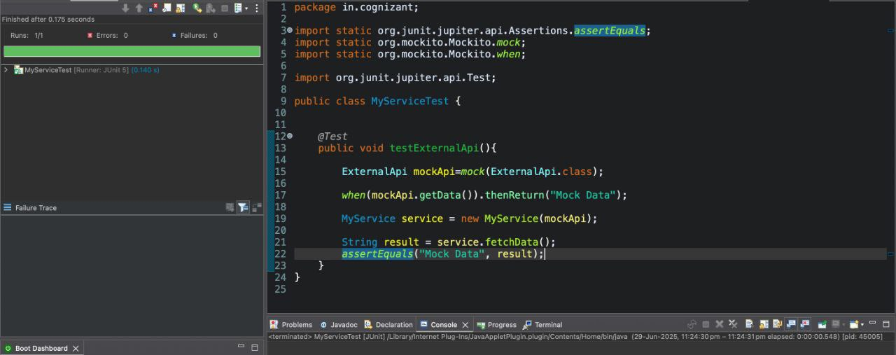
Output-

Exercise 2: Verifying Interactions
Scenario:
You need to ensure that a method is called with specific arguments.
Steps:
1. Create a mock object.
2. Call the method with specific arguments.
3. Verify the interaction.

Solution-
Adding dependencies:

<project xmlns="http://maven.apache.org/POM/4.0.0"
xmlns:xsi="http://www.w3.org/2001/XMLSchema-instance"
xsi:schemaLocation="http://maven.apache.org/POM/4.0.0 https://maven.apache.org/xsd/maven-4.0.0.xsd">

<modelVersion>4.0.0</modelVersion>
<groupId>in.cognizant</groupId>
<artifactId>MockitoExercises</artifactId>
<version>0.0.1-SNAPSHOT</version>

<dependencies>
<dependency>
<groupId>org.junit.jupiter</groupId>
<artifactId>junit-jupiter</artifactId>
<version>5.7.0</version>
<scope>test</scope>
</dependency>

<dependency>
<groupId>org.mockito</groupId>
<artifactId>mockito-core</artifactId>
<version>3.12.4</version>
<scope>test</scope>
</dependency>
</dependencies>

</project>

1. External API Interface

package in.cognizant;

public interface ExternalApi {
String getData();
}

2. Methods to return predefined values

package in.cognizant;

public class MyService {
private ExternalApi api;

public MyService(ExternalApi api) {
this.api = api;
}

public String fetchData() {
return api.getData();
}
}

3. Verify the interaction
package in.cognizant;

import static org.mockito.Mockito.mock;
import static org.mockito.Mockito.verify;
import org.junit.jupiter.api.Test;

public class MyServiceTest {
@Test
public void testVerifyInteraction() {
ExternalApi mockApi = mock(ExternalApi.class);
MyService service = new MyService(mockApi);
service.fetchData();
verify(mockApi).getData();
}
}

Output-
